**FIT-CLICK**

##### A Minor Project Report



##### Chhattisgarh Swami Vivekananda Technical University Bhilai, India

For

The partial fulfillment of Degree

### Bachelor of Technology

*in*

### Computer Science & Engineering

*By*

|  |  |  |
| --- | --- | --- |
| **Abhishek K Giri**  **Roll No: 303302218110**  **En. No. – BF4802**  **Semester 7th (CSE)** | **Nitish Gupta**  **Roll No: 303302218080**  **En. No. – BF4772**  **Semester 7th (CSE)** | **Yogesh Sonkar**  **Roll No: 303302218123 En. No. – BF4815**  **Semester 7th (CSE)** |

Under the Guidance of **Mr Devrat Sahu** Assistant Professor

Department of Computer Science & Engineering S.S.I.P.M.T, Raipur

### Department of Computer Science & Engineering Shri Shankaracharya Institute of Professional Management & Technology

**Raipur (C.G.)**

**Session: 2018 - 2022**

**DECLARATION BY THE CANDIDATE**

We the undersigned solemnly declare that the Major project report entitled **“*FIT-CLICK*”** is based our own work carried out during the course of our study under the supervision of Asst. Prof. **Devrat Sahu*.***

We assert that the statements made and conclusions drawn are an outcome of the project work. We further declare that to the best of our knowledge and belief that the report does not contain any part of any work which has been submitted for the award of any other degree/diploma/certificate in this University/Deemed university of India or any other country.

|  |  |  |  |
| --- | --- | --- | --- |
| **Abhishek K Giri Roll No.-303302218110**  **En. No. – BF4802**  **Semester 7th (CSE)** | **Nitish Gupta Roll No.-303302218080**  **En. No. – BF4772**  **Semester 7th (CSE)** | **Yogesh Sonkar Roll No.-303302218123 En. No. – BF4815**  **Semester 7th (CSE)** |  |

(Signature of the Supervisor)

Mr. Devrat Sahu

Assistant Professor, Dept of C.S.E. S.S.I.P.M.T

Raipur (C.G.)

# CERTIFICATE BY THE SUPERVISOR

This is to certify that the Major project report entitled **“FIT-CLICK”** is a record of project work carried out under my guidance and supervision for the fulfillment of the award of degree of Bachelor of Technology in the faculty of Computer Science & Engineering of Chhattisgarh Swami Vivekananda Technical University, Bhilai (C.G.) India.

To the best of my knowledge and belief the report

1. Embodies the work of the candidate himself
2. Has duly been completed
3. Fulfills the partial requirement of the ordinance relating to the B.Tech degree of the University
4. Is up to the desired standard both in respect of contents and language for being referred to the examiners.

(Signature of the Supervisor)

Mr. Devrat Sahu

Assistant Professor, Dept of C.S.E. S.S.I.P.M.T, Raipur (C.G.)

Forwarded to Chhattisgarh Swami Vivekanand Technical University

Bhilai

(Signature of HOD)

Dr. J.P. Patra

Dept. of Computer Science & Engineering S.S.I.P.M.T

Raipur, C.G

(Signature of the Principal)

Dr. Alok Kumar Jain

S.S.I.P.M.T

Raipur, C.G

# CERTIFICATE BY THE EXAMINERS

The project report entitled **“FIT-CLICK”** has been examined by the undersigned as a part of the examination of Bachelor of Technology in the faculty of Computer Science & Engineering of Chhattisgarh Swami Vivekanand Technical University, Bhilai.

Internal Examiner External Examiner

**Date: Date:**

**ACKNOWLEDGEMENT**

Presentation inspiration and motivation have always played a key role in the success of any venture. We pay our deep sense of gratitude to **Dr. J. P. Patra** (HOD, Dept. of Computer Science & Engg.) and express our sincere thanks to **Mr. Devrat Sahu** (Asst. Professor Dept. of Computer Science & Engg) our Mentor to encourage us to the highest peak and to provide us the opportunity to prepare this project. We are immensely obliged for their elevating inspiration, encouraging guidance and kind supervision in this project. So with due regards, we express our gratitude’s to them. We believe this endeavor of us and our parents has greatly boosted our self- confidence and will go long on helping us reach further milestones and greater heights. It is our delight to renowned the maximum cooperation and precious pointers made now and then with the aid of using our department's team of workers members, to whom we owe our complete knowledge, in addition to all the ones who've immediately or in a roundabout way assisted us with the aid of using offering books, laptop peripherals, and different essential services that assisted us with inside the development of this project.

Thank you for your guidance

(Signature of Candidate) (Signature of Candidate) (Signature of Candidate)

|  |  |  |
| --- | --- | --- |
| **Abhishek K Giri Roll No.-303302218110**  **En. No. – BF4802**  **Semester 7th (CSE))** | **Nitish Gupta Roll No.- 3302218080**  **En. No. – BF4772**  **Semester 7th (CSE)** | **Yogesh Sonkar Roll N0.-303302218123 En. No. – BF4815**  **Semester 7th (CSE)** |

**LIST OF ABBREVIATIONS**

|  |  |
| --- | --- |
| NPM | Node Package Manager |
| OS | Operating System |
| JS | JavaScript |
| RAM | Random Access Memory |
| ROM | Read Only Memory |
| GB | Gigabytes |
| MB | Megabytes |
| UI | User Interface |
| SDLC | Software Development Life Cycle |
| CLI | Command Line Interface |
| HTML | Hype Text Markup Language |
| MERN STACK | M: MongoDB  E: Express.js  R: React.js  N: Node.js |

**LIST OF FIGURES**

|  |  |  |  |
| --- | --- | --- | --- |
| **Sr. No.** | **Figure No.** | **Description** | **Page No.** |
| 1 | FIGURE 5.1 | Flowchart of Application Processing | 21 |
| 2 | FIGURE 5.3 | Waterfall Model | 26 |

**TABLE OF CONTENTS**

|  |  |  |
| --- | --- | --- |
| **CHAPTER** | **TITLE** | **PAGE NO.** |
| I | INTRODUCTION   * 1. Overview | **1-4** |
| II | PROJECT REVIEW  2.1 Project Review  2.2 Advantages | **5-8** |
| III | SOFTWARE REQUIREMENTS   * + 1. Developer’s requirements     2. End user’s requirements | **9-11** |
| IV | HARDWARE REQUIREMENTS   * + 1. Developer’s requirements     2. End user’s requirements | **12-15** |
| V | METHODOLOGY  5.1 Development approach  5.2.1 Factor affecting performance  5.3.1 Flow Chart Working  5.4.1 SDLC Model | **16-27** |
| VI | SNAPSHOTS | **28-31** |
| VII | FUTURE SCOPE  7.1 Future Scope | **32-33** |
| VIII | CONCLUSION  8.1 Conclusion | **34-35** |
| IX | REFERENCE | **36-38** |

#### ABSTRACT

* In this modern era where health is given priority, everyone wants to be physically fit and healthy. We have come up with the best form thing that helps us to stay fit and help us to stay focused that is yoga asana.

Yoga, an ancient practice and meditation, has become increasingly popular in today's busy society. For many people, yoga provides a retreat from their chaotic and busy lives. This is true whether you're practicing downward facing dog posture on a mat in your bedroom, in an ashram in India or even in New York City's Times Square. Yoga provides many other mental and physical benefits. Some of these extend to the kitchen table.

* That’s the reason why we have decided to develop yoga webapp. In this fast-paced life were

we have webapps for almost everything such as media, games, entertainment, finance,

and academics we also need a webapp to keep ourselves physically and mentally fit.

* The working of this web-app is as follows: -
  + This app will ask for user’s height, weight and then it will calculate BMI of the user.
  + Then it will suggest some yoga asanas according to the need of the user on the basis of the inputs provided earlier.
  + This webapp will also contain few more features like appointment from the doctor, diet plan, and basic yoga classes timely.

# Chapter 1 INTRODUCTION

## Chapter 1. Introduction

##### OVERVIEW

Yoga is an ancient physical and spiritual discipline and branch of philosophy that originated in India reportedly more than 5,000 years ago. The word yoga comes from the Sanskrit word yuj, which means to yoke, join, or unite. The Iyengar school of yoga defines yuj as the "joining or integrating of all aspects of the individual - body with mind and mind with soul - to achieve a happy, balanced and useful life." The ultimate aim of yoga, they claim, is to reach kaivalya (emancipation or ultimate freedom).

How does yoga work?

Yoga uses asanas (postures), focused concentration on specific body parts, and pranayama (breathing techniques) to integrate the body with mind and mind with soul.

Yoga asanas (postures or poses) help condition your body. There are thousands of yoga poses, and in Sanskrit, these poses are called kriyas (actions), mudras (seals), and bandhas (locks). A kriya focuses on the effort necessary to move energy up and down the spine; yoga mudra is a gesture or movement to hold energy or concentrate awareness; and a bandha uses the technique of holding muscular contractions to focus awareness.

Yoga focuses on the mind by teaching you to concentrate on specific parts of the body. For instance, you may be asked by the instructor to focus deeply on your spine, or let your mind go and have your body sink into the floor. This awareness keeps the mind-body connection sharp and doesn't allow a lot of time for external chatter (like worrying about what you're going to have for dinner or the presentation at the office that you're preparing for). Instead, the focus is internal, between your head and your body. An example is savasana (the corpse pose), which is practiced by virtually all schools of yoga. During savasana, you lie on your back with your eyes closed and just let your entire body sink into the floor. The idea is to not fight any thoughts you have, but to let them come and go while the instructor leads you through visual imagery to help you focus on how your muscles feel. The desired and often obtained result is to drift into a peaceful, calm, and relaxing state. Savasana is generally the final pose of a yoga session before final chanting and/or breathing exercises.

Yoga uses controlled breathing as a way to merge the mind, body, and spirit. The breathing techniques are called pranayama’s; prana means energy or life force, and yama means social ethics. It is believed that the controlled breathing of pranayama’s will control the energy flow in your body. It is my experience that controlled breathing helps me focus on muscles that are working, and during savasana, it slows down my heart rate, calms my mind, and leads to a deep, inner calm and sense of relaxation.

# Chapter 2 PROJECT REVIEW

## Chapter 2. Project Review

##### 2.1 Project Review

In this modern era where health is given priority, everyone wants to be physically fit and healthy. We have come up with the best form thing that helps us to stay fit and help us to stay focused that is yoga asana.

Yoga, an ancient practice and meditation, has become increasingly popular in today's busy society. For many people, yoga provides a retreat from their chaotic and busy lives. This is true whether you're practicing downward facing dog posture on a mat in your bedroom, in an ashram in India or even in New York City's Times Square. Yoga provides many other mental and physical benefits. Some of these extend to the kitchen table.

That’s the reason why we have decided to develop yoga webapp. In this fast-paced life where we have webapps for almost everything such as media, games, entertainment, finance, and academics we also need a webapp to keep ourselves physically and mentally fit.

The working of this web-app is as follows: -

* This app will ask for user’s height, weight and then it will calculate BMI of the user.
* Then it will suggest some yoga asanas according to the need of the user on the basis of the inputs provided earlier.
* This webapp will also contain few more features like appointment from the doctor, diet plan, and basic yoga classes timely.

**Advantages of Yoga: -**

1. **Your Time, Your Space**

Without the need to arrive at a studio at any certain time, online yoga allows you to select the time of the day that suits you to practice. Whether you’re a morning bird or a night owl, the ability to roll out your mat at any given time offers a great amount of freedom and allows you to commit to your practice in a way that is simple and easy. Perhaps you have just popped your baby down for a nap and have time to move or meditate. Maybe you’re traveling and taking your laptop allows you the opportunity to practice in your hotel room. Perhaps you have set up a sacred space in your own home where you love to flow. Online yoga offers an abundance of options and solutions for the modern-day yogi.

1. **A Plethora of Choice**

Let’s face it, we love choice. Online yoga allows you to browse and choose the class that you feel like diving into. You have the ability to select from different teachers, various styles, guest lectures, and special workshops. Flow with acclaimed teachers who you may never get the chance to practice with in ‘real life.’ Perhaps you wake up feeling like you need to open your hips. Maybe you feel energized and seek out an invigorating flow. Being able to choose what you feel like your body truly needs in a yoga class is empowering, liberating, and deeply satisfying.

1. **Absolute Comfort**

Perhaps you’re new to yoga and feel a little self-conscious in a studio. Perhaps you feel intimidated or find it hard to focus in a room full of other people. Online classes enable you to develop your practice in a comfortable environment whilst having the support of a teacher right there with you. Whether you are an advanced yogi looking to take your practice to the next level, or if yoga is an entirely new ballgame for you, having the space to build your own relationship with yoga makes it a deeply personal and nourishing experience.

### You Have a Pause Button

Literally! Another benefit of online yoga is the pause button. In a public yoga class, you can’t exactly ask everyone to pause while you practice your handstand for another minute. When you practice yoga at home, you can pause the class any time if you want a few extra minutes to practice a particular pose. That time isn’t always available when studio classes have to stick to set time slots. You can also rewind the video if you want to re-watch the teacher breaking down a new pose, or watch the teacher get into the pose before you try it yourself. Online yoga offers you more luxury in the time you have to play and learn . . . and pause.

## Yoga relaxes you, to help you sleep better.

[Research shows](https://www.hopkinsmedicine.org/health/wellness-and-prevention/yoga-for-sleep) that a consistent bedtime yoga routine can help you get in the right mindset and prepare your body to fall asleep and stay asleep.

# Chapter 3 SOFTWARE REQUIREMENTS

## Chapter 3.

**Software Requirements**

#### Software requirements.

Software plays a vital role in the development of any system. No matter in which language does the application has been developed. Software is that important part in any application that gives immense support in the development of any system. Software is a set of programs or coding that has been made for the better and easy performance of the computer. In project we have also used different software for developing it in an efficient manner.

##### Developer’s Requirement

* + - * Visual Studio Code.
      * NPM (Node Package Manager).
      * React.js.
      * Browsers.
      * OS (Windows 7, 8, 8.1, 10).

##### End User’s Requirement

* + - * Browsers (Chrome, Firefox, Edge, etc,)
      * Mobile browser.

##### Visual studio code

Visual Studio Code is a lightweight but powerful source code editor which runs on your desktop and is available for Windows, macOS and Linux. It comes with built-in support for JavaScript, TypeScript and Node.js and has a rich ecosystem of extensions

for other languages (such as C++, C#, Java, Python, PHP, Go) and runtimes (such as

.NET and Unity). It is a small but powerful source code editor that runs on your computer and is compatible with Windows, Mac OS X, and Linux.

##### NPM (Node Package Manager)

npm is the world's largest software registry. Open-source developers from every continent use npm to share and borrow packages, and many organizations use npm to manage private development as well.

npm consists of three distinct components:

* the website
* the Command Line Interface (CLI)
* the registry

Use the website to discover packages, set up profiles, and manage other aspects of your npm experience. For example, you can set up organizations to manage access to public or private packages.

The CLI runs from a terminal and is how most developers interact with npm.

The registry is a large public database of JavaScript software and the meta-information surrounding it.

* **React.js**

React is a JavaScript library for building user interfaces. Learn what React is all about [on our homepage](https://reactjs.org/) or [in the tutorial](https://reactjs.org/tutorial/tutorial.html). React has been designed from the start for gradual adoption, and you can use as little or as much React as you need**.** Whether you want to get a taste of React, add some interactivity to a simple HTML page, or start a complex React- powered app, the links in this section will help you get started.

* **MongoDB**

MongoDB is an open-source NoSQL database management program. NoSQL is used as an alternative to traditional relational databases. NoSQL databases are quite useful for working with large sets of distributed data. MongoDB is a tool that can manage document-oriented information, store or retrieve information.

* **Express.js**

Express.js is a web application framework for Node.js. It provides various features that make web application development fast and easy which otherwise takes more time using only Node.js.

* **Node.js**

Node.js is an open source, cross-platform runtime environment for developing server-side and networking applications. Node.js applications are written in JavaScript, and can be run within the Node.js runtime on OS X, Microsoft Windows, and Linux.

Node.js also provides a rich library of various JavaScript modules which simplifies the development of web applications using Node.js to a great extent.

# Chapter 4 HARDWARE REQUIREMENTS

## Chapter 4. Hardware Requirements

#### Hardware Requirements:

The role of hardware is as important as that of the software. If software requires adequate and accurate software, then it will also require a good hardware. The hardware configurations should be according to the need of the software that is being developed. The improper configurations of the hardware may lead to the undesirable result of the system being developed. The basic hardware required in our projects is the RAM, ROM and the processor of the system that is being used in the development of the project.

##### Developer’s Requirement:

* Intel Core i3 processor or above, 2 GHz or higher.

The processor is a logical circuit that responds to fundamental instructions and processes them in order to run a computer system. It is a prerequisite since a computer cannot function without it. Every time, an updated processor should be utilized to ensure that there is no misbehavior on the part of the processor.

* The disk requirement is 500 GB.

Another significant component of a computer system is the read-only memory (ROM). The ROM holds the computer's memory that can only be read and not updated to. The ROM enables us to boot the computer system whenever we turn it on. It does so by exposing some functionality.

* It requires a minimum of 4GB RAM. (Recommended 8GB).
* Internet Connection(1MBps).
* Graphics Card with dx10.

So, with the support of the above-mentioned hardware explanation, we can readily comprehend the significance of hardware in the creation of any computer system project. A system cannot function correctly without ideal hardware, hence appropriate and precise hardware is required while building or running any system

##### End User’s Requirement:

* + - * Intel Core i3 processor or above, 2 GHz or higher
      * Minimum RAM 2GB.
      * Storage Required 100MB.

##### RAM: 2GB or above

* RAM is short for “random access memory” and RAM is one of the most fundamental elements of computing. RAM is the super-fast and temporary data storage space that a computer needs to access right now or in the next few moments.
* The role of hardware is as important as that of the software. If software requires adequate and accurate software, then it will also require a good hardware. The hardware
* Configurations should be according to the need of the software that is being developed. The improper configurations of the hardware may lead to the undesirable result of the system being developed. The basic hardware required in our projects is the RAM, ROM and the processor of the system that is being used in the development of the project. The explanations of the requirements are as under.
* The RAM is another important part in the computer system. It is the storage device of a computer. The RAM stores the data and the machine codes that is being currently using up by the computer system. The space in the RAM should be adequate while developing or running the system developed. The inadequate amount of space in the RAM may lead to the improper functioning of the developed system. To avoid this proper RAM is to be used.

# Chapter 5 METHODOLOGY

## Chapter 5. Methodology

#### Methodology:

Methods include student meditation , Personalized yoga, online yoga teacher..

To get a transparent idea about the usage and implementation of the work, a survey was conducted to urge all the wants of yoga website. The info gathering method that is getting used for this survey may be a questionnaire.

The questionnaire consisted of varied research questions such as:

* + - What kind of yoga help does one needs?
    - What data is employed for self- analysis?
    - Did the categorized yoga helps?

The aims to supply an understanding of the specified data about clients performance that the client must improve the longer-term performances of themselve.

The aims to know the factors on which a client judges his/her performance.

This gives us a transparent picture of whether this tool helps the client and teachers to reinforce their performance or not. Below mentioned are the references drawn from the survey:

1. 78.25% of the clients preferred having such an evaluation system and agreed that the detailed analysis helped them in their academics as they need the convenience to try to do their analysis anywhere at any time, they need .21.75 you look after client disagreed because the method is time taking for them.
2. 87.67% of the cleint wanted to possess a tool for his or her analysis to enhance the tutorial performance. They also confirmed that this enabled them to assess individual client and help them perform better in their

Analysis.

#### Development Approach:

Web applications use a mixture of server-side scripts (Node.js and Express.js) to handle the storage and retrieval of the knowledge, and client-side scripts (JavaScript and HTML) to present information to users. We don't have to download or install web apps as they will be used with in-built browsers. They are easy to take care of and may be made for any device by making them responsive. Also, you would like to not update an internet application like we do with a mobile application because the web application is uploaded on a server and updates, or changes are made on the server side.

We used a web-application for our project because it is convenient for people of any age group. Also, it's simple to gather/store data through websites. The front is build using html, CSS, JavaScript.

##### Factors Affecting Academic Performance

# Possible factors responsible for physical performance improvement by yoga though it is low to moderate intensity of exercise in terms of % V.O2max , energy cost, MET and Percent MHR as observed in this study. Integratd from the findings of this study and those of [2, 7–10, 16, 34, 40, 43–45].

* Purpose: To examine the associations between overweight/obesity and occupation among Hispanics/Latinos, the largest minority population in the U.S. Methods: This study included 7,409 employed individuals in the Hispanic Community Health Study/Study of Latinos (HCHS/SOL), a prospective study of Hispanic/Latino individuals aged 18-74 in four communities in the U.S. We independently examined the relationships between BMI, Occupational Activity (OA), and Total Hours Worked, quantified via self-reported hours worked per week and occupation-assigned Metabolic Equivalents (METs). Results: More than three quarters of the participants were either overweight (39.3%) or obese (37.8%). Individuals with a primary occupation and those employed in a secondary occupation worked an average of 36.8 and 14.6 hrs/wk, respectively. The overall adjusted odds for being obese compared to normal weight were 3.2% (AOR = 1.03, 95% CI 1.01, 1.05) and 14.4% (AOR = 1.14 95% Cl 1.07, 1.23) greater for each 10 MET•hrs/wk unit of increased OA, and each 10-hrs/wk unit of Total Hours Worked, respectively. Conclusion: This study presents the first findings on the association between OA with overweight/obesity among Hispanic/Latino individuals in the U.S. Increasing OA and Total Hours Worked per week were independently associated with increasing odds of overweight/obesity suggesting that the workplace is only one part of the overall energy expenditure dynamic. Our findings point to the need to emphasize engaging employed individuals in greater levels of PA outside of the work environment to impact overweight/obesity.

#### Flow Chart:

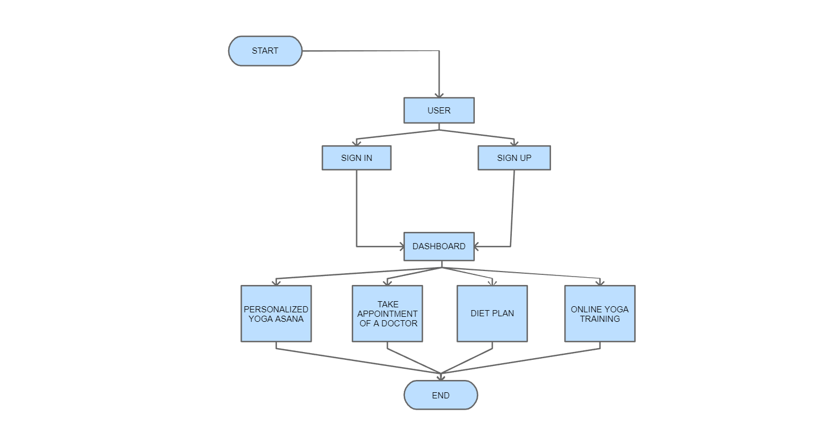

**Fig5.1 Flowchart of Application Processing**

##### Flowchart Working:

**Workflow**: -

1. First it will check that if user have account or not if they have account then they must fill the credentials in the login page, if not then they need to create an account to access the application’s features.
2. Once they have registered to website, they will reach the dashboard where they will have to fill their credentials like user’s height, weight, any serious disease they are suffering from (like hypertension, arthritis, etc.) and their preferred time to perform there yoga in a day.
3. Then, the user will come to the dashboard of the website where they will come across some options like Online Yoga, Diet plan, Appointment from doctor and Personalized Yoga asana.
4. If the user has selected the online yoga option: - At the time you have logged in matches to the time of online yoga class then it will direct you to the online meeting screen or else it will show the alter that no classes is available at that time.
5. If the user has selected the plan diet option: -If the user has selected the plan diet option, then it will show you the diet according to the input provided earlier.
6. If the user has selected the Appointment from the doctor option: - if the user has selected the appointment from the doctor option, then the website will try to get the appointment from the ayurvedic doctor asap.
7. If the user has selected the Personalized Yoga option:- If the user has selected the personalized yoga option then it will show you the yoga for you according to the input provided earlier.

##### Data Flow Diagram:

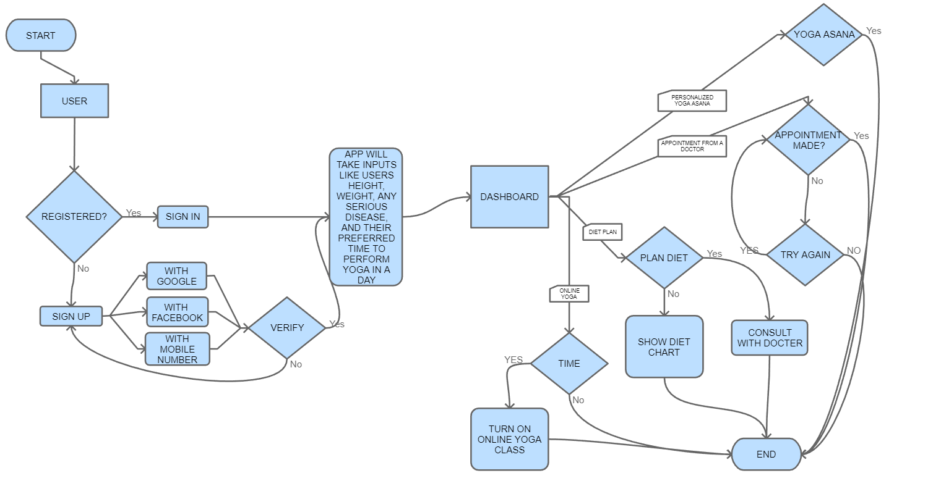

**Fig5.2 Data Flow Diagram**

##### Software Development Life Cycle:

The model uses to build this project is waterfall model. The Waterfall Model was the first Process Model to be introduced. It is also referred to as a linear-sequential life cycle model. It is very simple to understand and use. In a waterfall model, each phase must be completed before the next phase can begin and there is no overlapping in the phases.

The Waterfall model is the earliest SDLC approach that was used for software development. The waterfall Model illustrates the software development process in a linear sequential flow. This means that any phase in the development process begins only if the previous phase is complete. In this waterfall model, the phases do not overlap. Waterfall approach was first SDLC Model to be used widely in Software Engineering to ensure success of the project. In "The Waterfall" approach, the whole process of software development is divided into separate phases. In this Waterfall model, typically, the outcome of one phase acts as the input for the next phase sequentially.

The sequential phases in Waterfall model are –

* + - * **Requirement Gathering and analysis** − All possible requirements of the system to be developed are captured in this phase and documented in a requirement specification document.
      * **System Design** − The requirement specifications from first phase are studied in this phase and the system design is prepared. This system design helps in specifying hardware and system requirements and helps in defining the overall system architecture.
      * **Implementation** − With inputs from the system design, the system is first developed in small programs called units, which are integrated in the next phase. Each unit is developed and tested for its functionality, which is referred to as Unit Testing.
      * **Integration and Testing** − All the units developed in the implementation phase are integrated into a system after testing of each unit. Post integration the entire system is tested for any faults and failures.
      * **Deployment of system** − Once the functional and non-functional testing is done; the product is deployed in the customer environment or released into the market.
      * **Maintenance** − There are some issues which come up in the client environment. To fix those issues, patches are released. Also to enhance the product some better versions are released. Maintenance is done to deliver these changes in the customer environment.

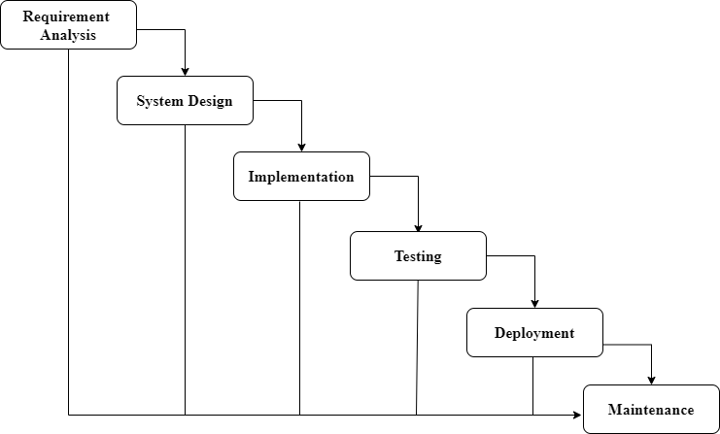

**Fig5.3 Waterfall Model**

##### Waterfall Model – Application

Every software developed is different and requires a suitable SDLC approach to be followed based on the internal and external factors. Some situations where the use of Waterfall model is most appropriate are −

* + - * Requirements are very well documented, clear and fixed.
      * Product definition is stable.
      * Technology is understood and is not dynamic.
      * There are no ambiguous requirements.
      * Ample resources with required expertise are available to support the product.
      * The project is short.

##### Waterfall Model – Advantages

* + - * Simple and easy to understand and use
      * Easy to manage due to the rigidity of the model. Each phase has specific deliverables and a review process.
      * Phases are processed and completed one at a time.
      * Works well for smaller projects where requirements are very well understood.
      * Clearly defined stages.
      * Well understood milestones.
      * Easy to arrange tasks.
      * Process and results are well documented.

# Chapter 6 SNAP SHOTS

## Chapter 6.

## Snapshots

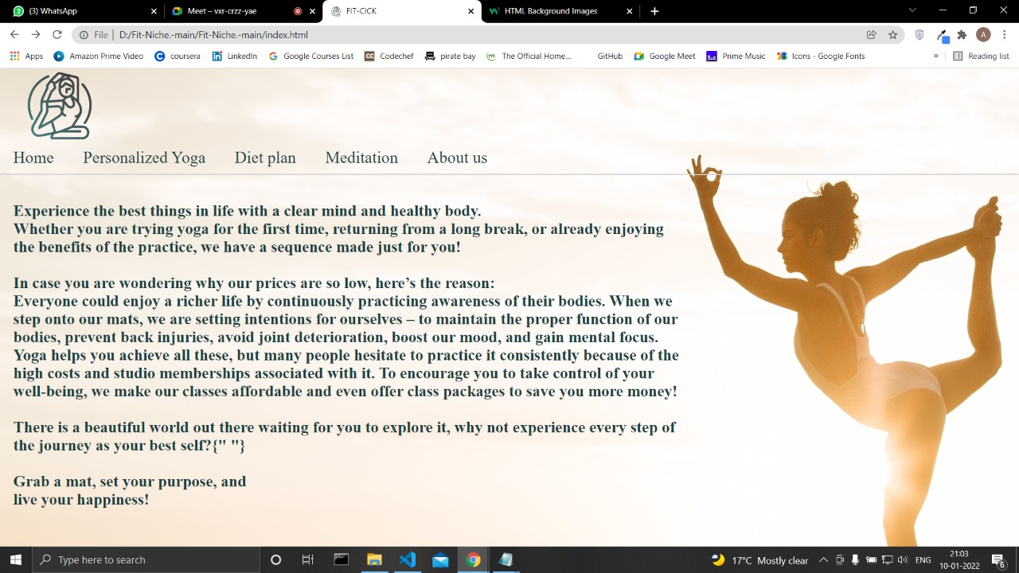

**Fig6.1 Home Page**

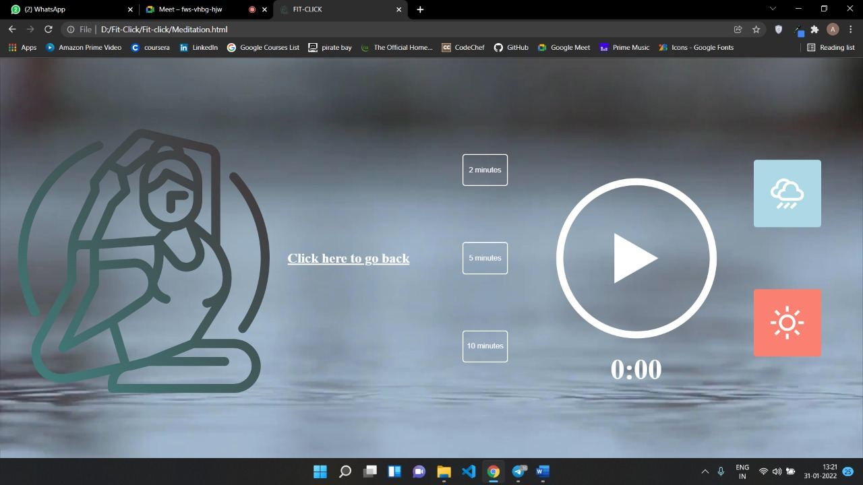

**Fig6.2 Meditation Page**

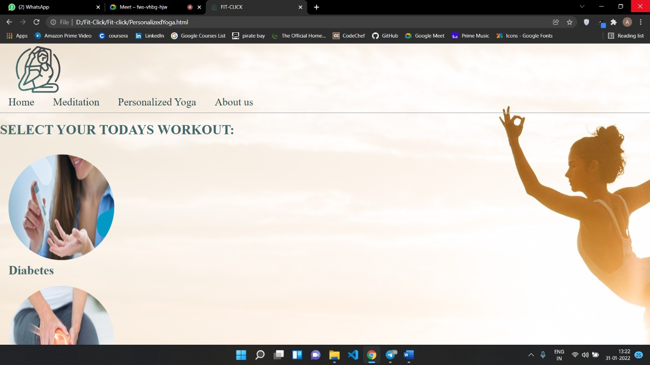

**Fig6.3 Personalized Yoga Page**

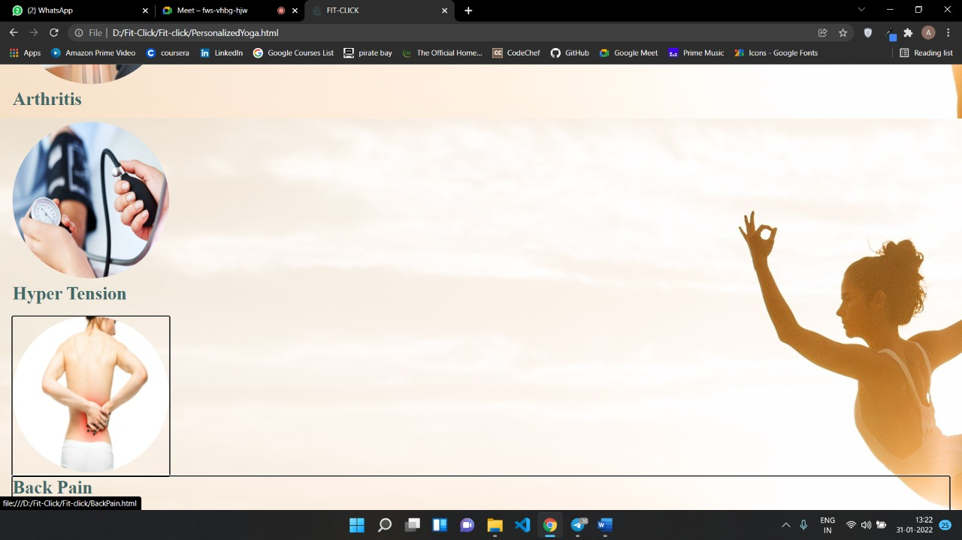

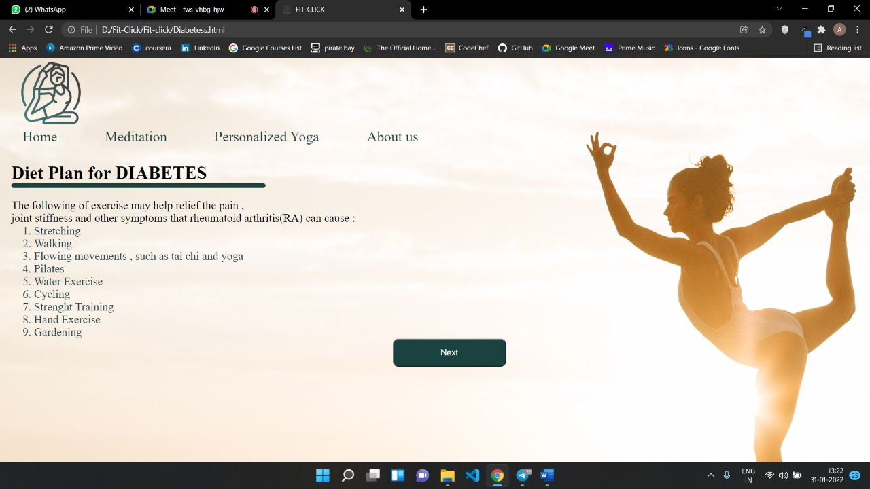

**Fig6.4 Diet Plan Page**

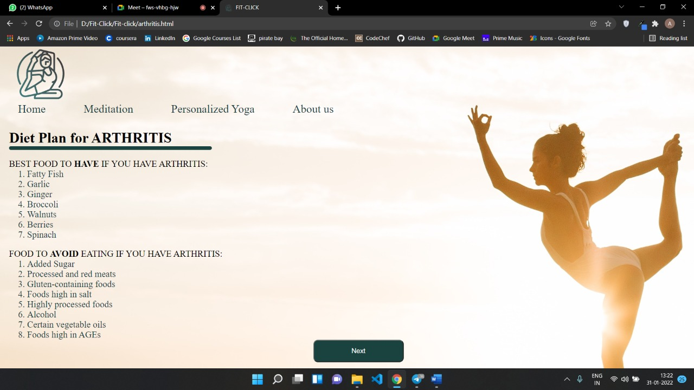

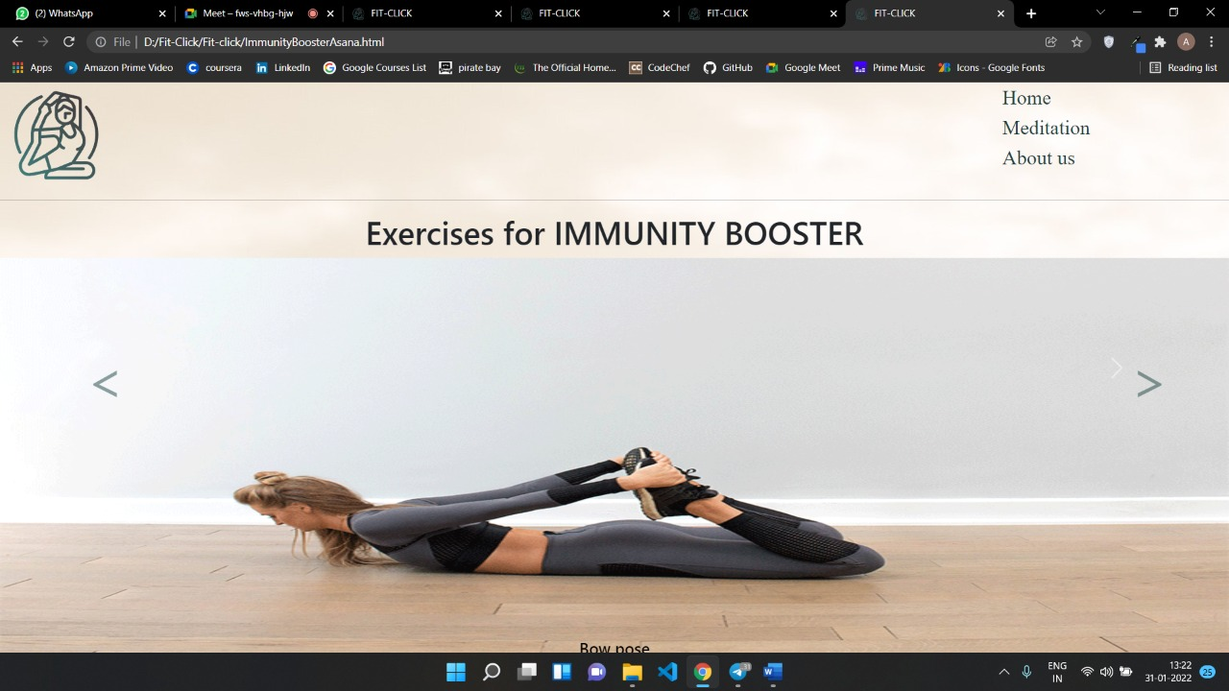

**Fig6.5 Exercise Page**

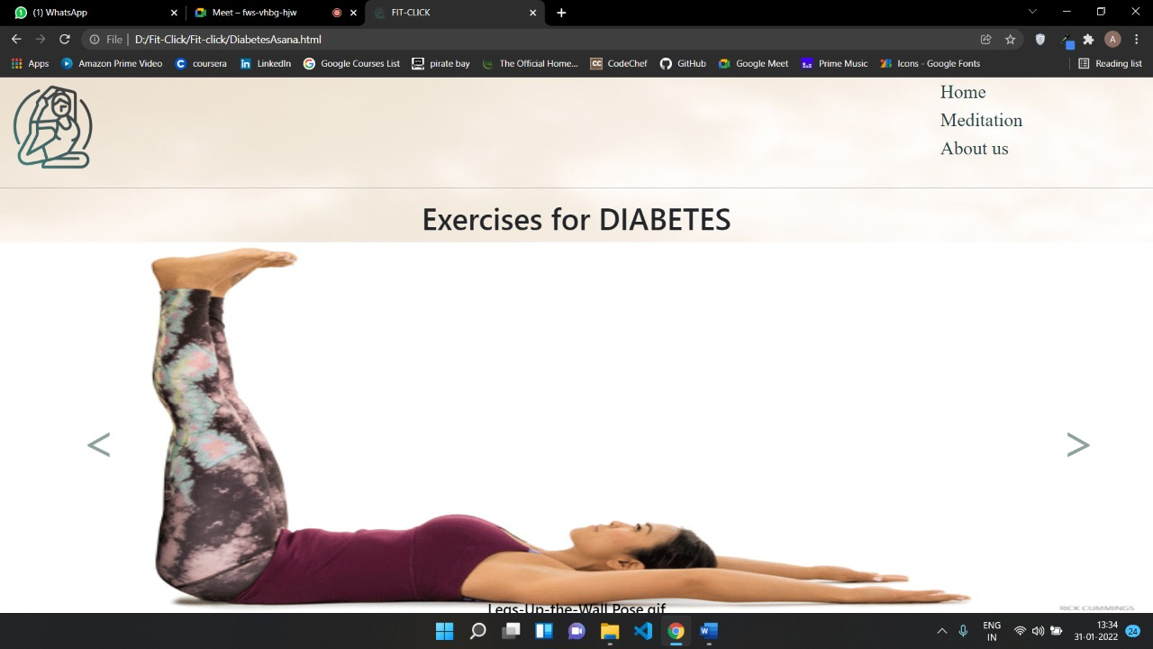

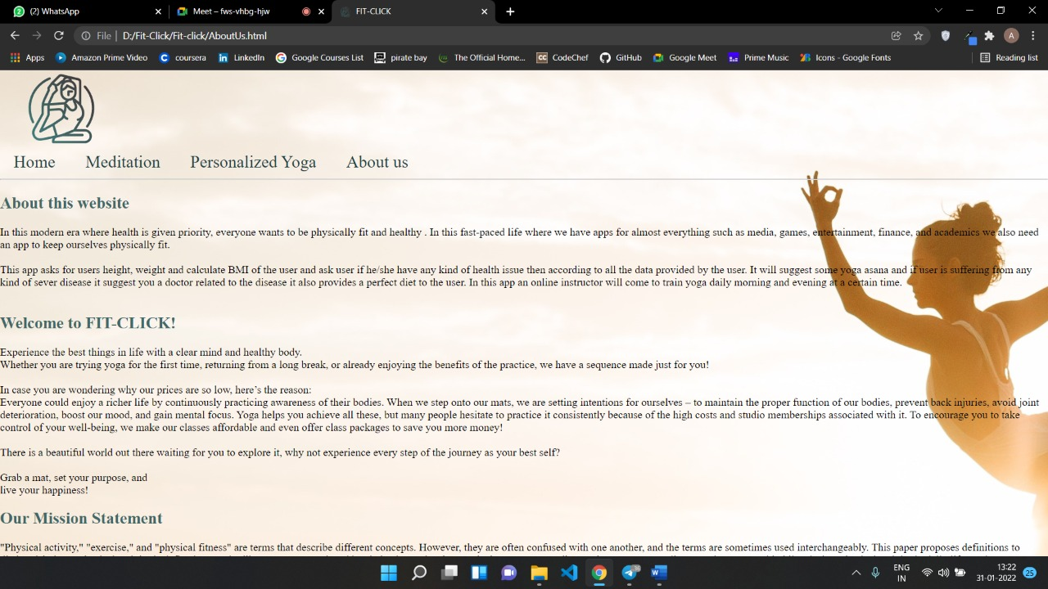

**Fig6.6 About Us**

# Chapter 7 FUTURE SCOPE

## Chapter 7. Future Scope

**Future Scope:**

Our application currently only works on static data and displays information which has to be changed at regular time intervals for getting the proper visualization of information. To further improve the web application, we can make use of machine learning and data science technologies. Through this anyone can benefit even more as they would also be able to get diet plan and the appointment from the doctor.

This application is currently web-based application and performing all the task, but user must have full internet access to use the application. As previously told the application is web-based user need browser to open it but in future we are going to build an application for this so that there will be of paid and free of cost feature browsers user can easily add, update and able to get output on basis of their subscription, in their smartphone anytime anywhere in the graphical form that will make it easy to understand. The application will also predict based on the output where the student needs to focus and need to improve that feature will be added in future mobile application, as there no paid feature.

According to our research, in this time of pandemic also where everyone is trying to be fit, increase immunity, exercise more people are looking for some trainers. So what would be anything better then staying home and get the instructor with only one click.

# Chapter 8 CONCLUSION

## Chapter 8. Conclusion

#### Conclusion:

To conclude the fundamental principle of “Yoga in Daily Life” is religious freedom. Yoga is not a religion - it is the source of spirituality and wisdom, the root of all religions. Yoga transcends religious boundaries and reveals the way to unity. “Yoga in Daily Life” offers the spiritual aspirant guidance on life’s path through the practices of Mantra Yoga and Kriya Yoga. As the most highly developed beings upon earth, humans are capable of realizing their real nature and inner Self, God. The spiritual goal of Yoga is God-Realization, the union of the individual soul with God. The realization that we are all one in our common root and connection to God is the first step. Decisions regarding your health and Wellbeing and a free, happy life, are in your hands. Practice regularly with firm determination and success will be certain. I wish all Yoga practitioners and those still to become practitioners much happiness, success, health, harmony, joy in life and God's blessing

• This website helps user to get a better health and mental stability by making use of the inputs provided by the user it provides yoga asanas and if user is suffering from any major health issue which user. mention in the input it suggests you to some doctor or specialist.

• This webapp helps user with their diet plans according to the health issues they are facing which is not being provides by any of the websites usually.

• You don’t have to go anywhere to learn yoga you can learn in your home.

• As most of the things are free of cost in this website so it is cost efficient.

**Yoga and personality development**

Personality**:** The term personality defines what the individual is. In contemporary psychology,

personality has been examined in a few different ways. Psychologist talk about personality as qualities

within an individual and characteristic ways of behavior of an individual. Personality development has

several interrelated dimensions namely, physical, intellectual, emotional, social and spiritual.

For yogic point of view the person is viewed as a spiritual entity, connecting in the material world,

utilizing body/mind as a vehicle. Human being here is seen as an autonomous spiritual consciousness,

independent of the body. Yogic philosophy views the person as having five koshas which surround the

divine self or the atman. These shealths, from the outermost to innermost order are known as Annamaya

Kosha (physical body), Pranamaya Kosha (energy body), Manomaya Kosha (mental body)Vijnanamaya

Kosha (bliss body). Inner shreaths are related to the higher levels of consciosness while the outermost

shreaths is related to the outward going or lower level of consciousness.

Personality Development through Yoga

Yoga is considered as an effective tool for development of personality of children. Yoga acts on all five

koshas (shreaths) surrounding the self.

Asanas are the tools which mainly influence annamaya kosha by bringing flexibility, relaxation, toning,

strength, balance and general fitness. Various researches have revealed that at the pranamaya kosha or

the subtle energy level, pranayama restores harmony to the flow of prana (vital force) by removing

blocks and imbalances. The manomaya kosha works at two levels, the level of mind and the level of

emotion. At the mental level, dharna, dhyana and smadhi facilitate channelization of thoughts and then

focus on a single thought leading to the state of super consciousness. At the emotional level, Bhakti

Yoga is good for culturing emotion. It gives emotion the right direction for growth. By devotional

practices, negative, harsh and violent emotions can be replaced with the positive, soft and gentle

emotions. Thus, Dhyan and Bhakti Yoga facilitate the mental and emotional development of the

children. Dhyana and Jnana Yoga are helpful to reach the level of higher buddhi.

Good intellect, intuition, wisdom, higher knowledge and psychic abilities shine out from the innermost

sheath(anandmaya kosha). Love, compassion, joy, accomplishment and mutually fulfilling relationships

get evolvd from the crude level to a more refined level. This will help to evolve better intra-personal and

interpersonal relationships. Ananamaya kosha (bliss body) is the ineffable experience of peace, love and

ecstasy from being in contact with the ultimate consiciousness which can be reached by attaining the

state of smadhi.

Yoga for Physical Development

Physical Growth is an ideal body means proportionate body with all the muscles relaxed in a normal

state, all systems and organs of body with least abnormality and absence of ailments. Yogic practices

can play positive role in promotion of wellness and in prevention and curing various ailments and

diseases of the body and in making the body work more efficiently. Well proportionate body and

flexibility in the muscles and parts of body can be attained with the help of various asanas or postures.

Contribution of Yoga to the physical development of personality has been proved time and again.

Yoga for cognitive development

Mental development is the growth and change in cognitive processes such as attention, memory,

thinking, perceiving, imagination, reasoning and problem solving. It is a continuous process which

continuous without any interruption during all the stages of life. Surya Namaskar, Tratak and Pranayama

helped to maintain the pineal gland (responsible for development of cerebral faculty) and beneficial for

learning, retaining information and memory.

Yoga for Emotional Development

Emotional development can be considered in terms of control and expression of emotions as well as

management of relationships with oneself and others. Stretching exercises, relaxation techniques and

pranayams are good tools for conditioning the autonomous nervous system. These yogic practices have

been found to bring significant positive changes in the emotional states of anxiety, stress, depression,

regression, fatigue, guilt and arousal.

Yoga for Social Development

Social development refers to the development of attitudes and behavior in relation to others behavior.

The process by which attitudes and behavior of a child are brought into harmony with others is called

socialization.Yama, Niyama, Pratyahar and Dhyana of Ashtang Yoga can be important tools for social

development.

Yoga for spiritual development

The texts on Yoga describe the spiritual health as self-awareness of ones natural state of contentment.

Spiritual development takes place in the form of habit, values, ethics etc. Good habits and a strong value

system inculcated right from the childhood will have lasting effects on the personality of a child.

Dhyana is a powerful tool for a spiritual growth. Teaching and practice of Yama, Niyama and

Meditation (Dhyana) are also beneficial for spiritual growth.

# Chapter 9 REFERENCES

## Chapter 9.

#### REFERENCES:

**References**

1. https://colorlib.com/wp/portfolio-tag/yoga/.
2. https://www.researchgate.net/publication/342916678_A_study_on_influence_of_yoga_on_student's_life.
3. https://www.youtube.com/watch?v=CGGF6MOOdrw&t=164s.
4. https://www.mdpi.com/1660-4601/17/19/6967.
5. Fan Yang, Frederick W.B. Li, “Study on student performance estimation, student progress analysis, and student potential prediction based on data mining”, Computers & Education, Volume 123, 2018, Pages 97- 108, ISSN 0360-1315.
6. Saraiya, P., North, C., Duca, K, “An Insight Based Methodology for Evaluating Bioinformatics Visualization”, IEEE Transactions on Visualizations and Computer Graphics, Vol. 11, No. 4, 2005 July/August.
7. Pathan Bilkish Asma Aslam, “Online Student Performance Analysis System”, INTERNATIONAL JOURNAL OF ADVANCE SCIENTIFIC RESEARCH AND ENGINEERING TRENDS, November 2018, Volume 3, Issue 11, November 2018, ISSN (Online) 2456-0774
8. Disha Kalambe, Anita Labade, Surabhi Khedekar, Komal Mahajan, “Student Performance Analysis System using Data Mining”, INTERNATIONAL JOURNAL OF ENGINEERING RESEARCH & TECHNOLOGY (IJERT), 2017, Volume 5, Issue 01.
9. Sri Laxmi Kuna, A.V. Krishna Prasad, “Research Methodologies for Student Performance Evaluation Using Educational Analytics Tools and Approaches”, International Journal of Recent Technology and Engineering (IJRTE), Volume-8, Issue-1S4, June 2019, ISSN: 2277- 3878
10. Nancy Safer and Steve Fleischman, “How Student Progress Monitoring Improves Instruction”, Educational Leadership, February 2005, Volume 62, Number 5, Pages 81-83.

PERFORMANCE EVALUATION

Devrat Sahu

Assistant Professor, Department of Computer Science & Engineering, Shri Shankaracharya Institute of Professional Management and Technology, Raipur, Chhattisgarh, India

**devrat.sahu@ssipmt.com**

Yogesh Sonkar

B. Tech Department of Computer Science & Engineering, Shri Shankaracharya Institute of Professional Management and Technology, Raipur, Chhattisgarh, India

**yogeshsonkar@gmail.com**

Abhishek K. Giri

B. Tech Department of Computer Science & Engineering, Shri Shankaracharya Institute of Professional Management and Technology, Raipur, Chhattisgarh, India

**Abhishek.giri1617@gmail.com**

Nitish Gupta

B. Tech Department of Computer Science & Engineering, Shri Shankaracharya Institute of Professional Management and Technology, Raipur, Chhattisgarh, India

**nitish.gupta1503@gmail,com**

**Abstract -**

[38]